# freETarget

Application Note: Going Wireless

**SUMMARY**

This application note details the components and configuration needed to implement a wireless connection.

The application

**REQUIRED**

|  |  |  |
| --- | --- | --- |
| Item | Description | Obtained From Amazon or Similar |
| 1 |  | freETarget V3.0 or higher |
| 2 |  | freETarget firmware 4.0.0 or higher |
| 3 | ESP-01 | <https://www.amazon.com/Wireless-Transceiver-Receiver-DC3-0-3-6V-Compatible/dp/B07R4MXPLF/ref=sr_1_12?crid=3V1D0J59OCRTH&dchild=1&keywords=esp-01&qid=1624114287&sprefix=esp-01%2Caps%2C169&sr=8-12> |
| 4 | ESP-01 5Volt Adapter | <https://www.amazon.com/Aideepen-ESP8266-Wireless-Adapter-Compatible/dp/B01M09B43H/ref=sr_1_3?dchild=1&keywords=esp-01+5V&qid=1624114362&sr=8-3> |
| 5 | 2x6 Pin IDC Connector | https://www.digikey.com/en/products/detail/te-connectivity-amp-connectors/3-640441-6/698225 |
| 6 | 24 Gauge Wire |  |

**OPTIONAL**

|  |  |  |
| --- | --- | --- |
| Item | Description | Obtained From |
| 1 | 9 Volt Power Supply | <https://www.amazon.com/iCreatin-Adapter-Arduino-Tbuymax-Positive/dp/B07CR1BY9M/ref=sr_1_5?keywords=arduino+power+supply&qid=1645196707&sr=8-5> |

**INTRODUCTION**

freETarget supports a WiFi connection using the accessory connector and an off-the-shelf ESP-01 Serial WiFi transceiver. freETarget supports two modes of operation:

* Preset SSID, FET-target_name that allows for simple use of the WiFI
* Custom SSID that allows freETarget to be on your home network along with things like Scatt and TeamViewer.

Installing the ESP-01 consists of the following steps

* Build the ESP-01 interface
* Attach the ESP-01 to freETarget
* Select the target name
* Power Up
* Configure the freETarget SSID for your network

**ASSEMBLING THE WiFi INTERFACE**

**Building the ESP-01 Adapter**

The ESP-01 is a self-contained circuit that operates at 3.3 Volts. freETarget operates at 5.0 Volts, so connecting an ESP-01 directly to the board will damage the ESP-01 circuit. Fortunately, adapter circuits are available that convert the voltage levels. Install the ESP-01 into the adapter as shown in Figure 1.

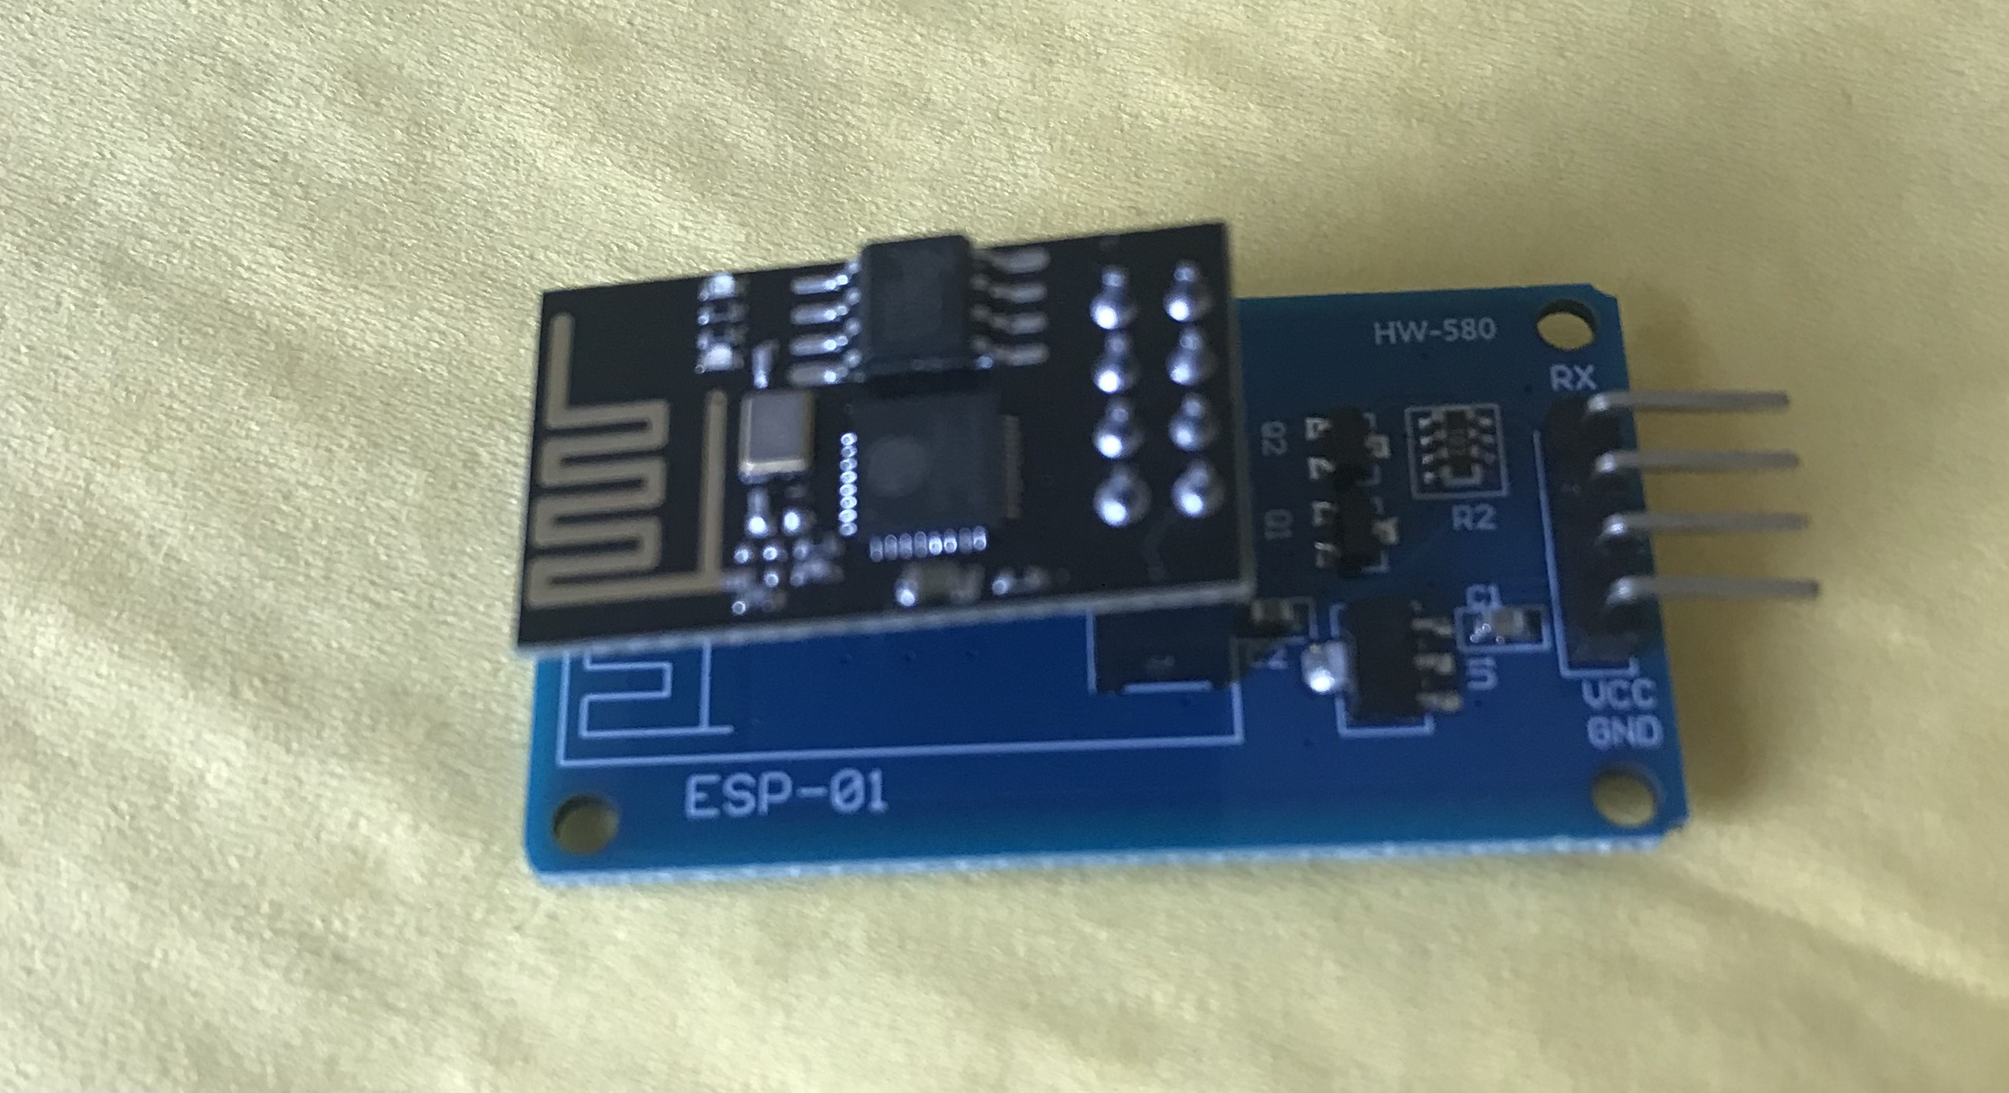

Figure 1: ESP-01 and Adapter Assembly

The ESP-01 and freETarget connect to each other using a short six pin connector illustrated in Figure 2. While the ESP-01 adapter uses four pins and freETarget uses six, for the purposes of convenience two six pin connectors can be used.

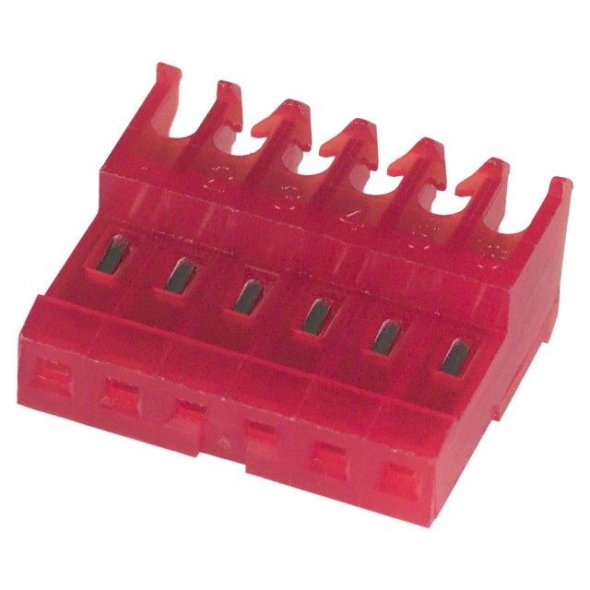

Figure 2: Sample IDC Connector

The wiring for each of the connectors is found in Table 1 and Figure 3

Table 1: WiFI Cable Harness with Colours

|  |  |  |  |  |
| --- | --- | --- | --- | --- |
| freETarget  Connector |  | Description | ESP-01  Connector |  |
| 1 | Red | 5VDC | 2 | Red |
| 2 | White | Auxiliary Transmit Data | 4 | White |
| 3 | Yellow | Auxiliary Receive Data | 3 | Yellow |
| 4 | TBD | Motor Drive (Not Used) |  | TBD |
| 5 |  | Spare (Not Used) |  |  |
| 6 | Black | Ground | 1 | Black |

|  |  |
| --- | --- |
|  |  |
| Figure 3: WiFi Cable on Arduino | WiFi Cable on ESP-01 |

**Connect the ESP-01 to freETarget using the cable harness.**

IMPORTANT

When connecting the cable harness to the ESP-01, ensure that Pin 1 of the connector mates to Pin 1 of the adapter. Pins 5 and 6 will overhang the board and not be connected.

**CHOICES**

At this point you can choose:

* Easy installation that fixes the SSID to FET-target_name and you simply link up to the target.
* Network installation that lets you put one or more freETargets on the same network along with your other devices

**EASY INSTALLATION (DEFAULT)**

**Naming the Target**

freETarget allows you to assign a name to each target for identification. This name appears in the SSID of the WiFi sources on your computer. If you are using a single lane freETarget, the default name “FET-TARGET” can be used for the SSID.

In larger installations a name can be chosen from Table. Use NAME setting found in the PC program setup tab.

Table 2: freETarget Lane Names

|  |  |
| --- | --- |
| Name ID |  |
| 0 | TARGET |
| 1-10 | Numeric 1-10 |
| 11-18 | Seven Dwarfs  “DOC", "DOPEY", "HAPPY", "GRUMPY", "BASHFUL", "SNEEZEY", "SLEEPY" |
| 19-27 | Eight Reindeer  "RUDOLF", "DONNER", "BLITZEN", "DASHER", "PRANCER", "VIXEN", "COMET", "CUPID", "DUNDER" |
| 28-32 | Norse Gods  "ODIN", "WODEN", "THOR", "BALDAR" |

**Native WiFi Support**

Starting with Version 3.0.3 of the PC program WiFi support is built into the program and can be used in the same manner as the USB Serial Port

Launch the program and under the settings icon (Gear Wheel), General Tab, look for the Communication Protocol selection (Figure 4). Make sure that TCP is selected and that the IP address is as shown.

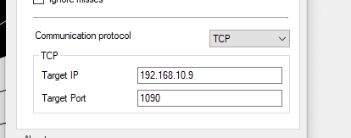

Figure 4: Communication Protocol Selection

Press CONNECT to connect to the freETarget. The program will show the freETarget firmware version. Only 3.4.8 and higher will work correctly.

**TROUBLESHOOTING**

If your freETarget is not working with the PC program, carry out the following checks

* Connect to the freETarget using the conventional COM port.
  + Connect to the board
  + Using the Arduino Button examine the settings
    - Does the string “WiFi”:1 appear?
      * The ESP-01 WiFi adapter is connected and recognized by the Arduino
    - Does the string “WiFI”:0 appear?
      * The ESP=01 WiFi adapter is not connected
      * Verify the cable harness and connections
* Verify that the PC program has the correct connection (TCP) and IP addresses

**Setting the PC SSID**

The PC must be on the same SSID as the target. For simplicity, the target generates it’s own SSID and address that your PC must connect to.

To change your PC SSID from your PC setup follow these steps

1 – Setup

2 – Network & Internet

3 – WiFi Show Available Networks

4 – Choose FET-



**SPECIFICATIONS**

When an ESP-01 is attached to freETarget, the firmware will detect the ESP-01 and automatically configure the connection.

**SSID**

The WiFi SSID connection will take on the name of the target, FET-<name>. For example FET-TARGET or FET-RUDOLF.

**freETarget IP Address**

The freETarget IP address is fixed and is 192.168.10.9

**PC IP Address**

The ESP-01 contains a DHCP server and will assign the PC an address of 192.168.10.0

**Server Connection**

The PC acts as a client to freETarget, and connects to freETarget on port 1090

**NETWORK INSTALLATION**

Starting with Version 4.0, FreeTarget allows you to put the target on the same network as the rest of your system. To do so, you need to connect freeETarget to your PC using the USB cable and configure it manually.

There are four steps to follow

1. Connect to the PC using the USB cable
2. With the configuration tool
   1. Set the SSID you want to be on
   2. Optional - set the Password
   3. Optional – Set the IP address
3. Reset the target
4. Enter the network information into the PC

**Connect the PC with USB**

Until the network connection is established, you need to configure the target with a USB cable

* Connect to the target with the USB as you would normally
* Using the Arduino tab, set the SSID and Password
  + Leaving the SSID blank {“WIFI_SSID”:””} puts the target into the default mode
  + Leaving the PWD blank {WIFI_PWD”:””} connects to an open network
  + 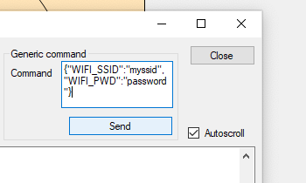
* Hit Send
* Unplug / Plug the target to reset the settings
* Connect to the target again
* Using the Arduino tab, verify that the SSID and Password have connected you to the network. Look for

"WiFi_PRESENT": 1,

"WiFi_IP_ADDRESS": “192.168.1.23:1090",

* If the IP address is blank then repeat the SSID and Password steps
* Fix the IP address of the target to the same IP address as you found before (do not include the “:1090”)
  + Leaving the IP address blank {“WIFI_IP”:””} lets the router assign the IP address and may change every time you connect to the target.

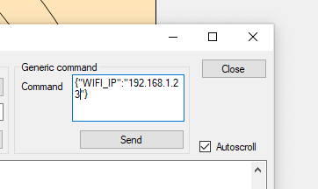

* Exit the Arduino tab and enter the setup tab
* Configure the Communications protocol to match your target
* 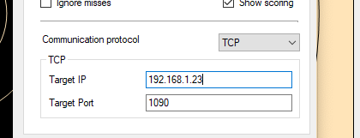
* Disconnect and reconnect to the target to verify the operation